How To Secure Nginx with Let's Encrypt on CentOS 8
NginxLet's EncryptCentOS 8

- By Vadym Kalsin
Published onDecember 2, 2020 7.2k views

Not using CentOS 8?
Choose a different version or distribution.
The author selected the COVID-19 Relief Fund to receive a donation as part of the Write for DOnations program.

Introduction
Let’s Encrypt is a certificate authority (CA) that provides free certificates for Transport Layer Security (TLS) encryption. It simplifies the process of creation, validation, signing, installation, and renewal of certificates by providing a software client—Certbot.
In this tutorial you’ll set up a TLS/SSL certificate from Let’s Encrypt on a CentOS 8 server running Nginx as a web server. Additionally, you will automate the certificate renewal process using a cron job.

Prerequisites
In order to complete this guide, you will need:
- One CentOS 8 server set up by following the CentOS 8 Initial Server Setup guide, including a non-root user with sudo privileges and a firewall.
- Nginx installed on the CentOS 8 server with a configured server block. You can learn how to set this up by following our tutorial How To Install Nginx on CentOS 8.
- A fully registered domain name. This tutorial will use your_domain as an example throughout. You can purchase a domain name on Namecheap, get one for free on Freenom, or use the domain registrar of your choice.
- Both of the following DNS records set up for your server. You can follow this introduction to DigitalOcean DNS for details on how to add them.
  - An A record with your_domain pointing to your server’s public IP address.
  - An A record with www.your_domain pointing to your server’s public IP address.

Step 1 — Installing the Certbot Let’s Encrypt Client
First, you need to install the certbot software package. Log in to your CentOS 8 machine as your non-root user:
ssh sammy@your_server_ip

The certbot package is not available through the package manager by default. You will need to enable the EPEL repository to install Certbot.
To add the CentOS 8 EPEL repository, run the following command:
sudo dnf install epel-release

When asked to confirm the installation, type and enter y.
Now that you have access to the extra repository, install all of the required packages:
sudo dnf install certbot python3-certbot-nginx

This will install Certbot itself and the Nginx plugin for Certbot, which is needed to run the program.
The installation process will ask you about importing a GPG key. Confirm it so the installation can complete.
You have now installed the Let’s Encrypt client, but before obtaining certificates, you need to make sure that all required ports are open. To do this, you will update your firewall settings in the next step.

Step 2 — Updating the Firewall Rules
Since your prerequisite setup enables firewalld, you will need to adjust the firewall settings in order to allow external connections on your Nginx web server.
To check which services are already enabled, run the command:
sudo firewall-cmd --permanent --list-all

You’ll receive output like this:
Output
public
target: default
icmp-block-inversion: no
interfaces:
sources:
services: cockpit dhcpv6-client http ssh
ports:
protocols:
masquerade: no
forward-ports:
source-ports:
icmp-blocks:
rich rules:
If you do not see http in the services list, enable it by running:
sudo firewall-cmd --permanent --add-service=http

To allow https traffic, run the following command:
sudo firewall-cmd --permanent --add-service=https

To apply the changes, you’ll need to reload the firewall service:
sudo firewall-cmd --reload

Now that you’ve opened up your server to https traffic, you’re ready to run Certbot and fetch your certificates.

Step 3 — Obtaining a Certificate
Now you can request an SSL certificate for your domain.
When generating the SSL Certificate for Nginx using the certbot Let’s Encrypt client, the client will automatically obtain and install a new SSL certificate that is valid for the domains provided as parameters.
If you want to install a single certificate that is valid for multiple domains or subdomains, you can pass them as additional parameters to the command. The first domain name in the list of parameters will be the base domain used by Let’s Encrypt to create the certificate, and for that reason you will pass the top-level domain name as first in the list, followed by any additional subdomains or aliases:
sudo certbot --nginx -d your_domain -d www.your_domain

This runs certbot with the --nginx plugin, and the base domain will be your_domain. To execute the interactive installation and obtain a certificate that covers only a single domain, run the certbot command with:
sudo certbot --nginx -d your_domain

The certbot utility can also prompt you for domain information during the certificate request procedure. To use this functionality, call certbot without any domains:
sudo certbot --nginx

You will receive a step-by-step guide to customize your certificate options. Certbot will ask you to provide an email address for lost key recovery and notices and to agree to the terms of service. If you did not specify your domains on the command line, Certbot will look for a server_name directive and will give you a list of the domain names found. If your server block files do not specify the domain they serve explicitly using the server_name directive, Certbot will ask you to provide domain names manually.
For better security, Certbot will automatically configure redirecting all traffic on port 80 to 443.
When the installation successfully finishes, you will receive a message similar to this:
Output
IMPORTANT NOTES:
- Congratulations! Your certificate and chain have been saved at:
/etc/letsencrypt/live/your_domain/fullchain.pem
Your key file has been saved at:
/etc/letsencrypt/live/your_domain/privkey.pem
Your cert will expire on 2021-02-26. To obtain a new or tweaked
version of this certificate in the future, simply run certbot again
with the "certonly" option. To non-interactively renew *all* of
your certificates, run "certbot renew"
- If you like Certbot, please consider supporting our work by:

Donating to ISRG / Let's Encrypt: https://letsencrypt.org/donate
Donating to EFF: https://eff.org/donate-le

The generated certificate files will be available within a subdirectory named after your base domain in the /etc/letsencrypt/live directory.
Now that you have finished using Certbot, you can check your SSL certificate status. Verify the status of your SSL certificate by opening the following link in your preferred web browser (don’t forget to replace your_domain with your base domain):
https://www.ssllabs.com/ssltest/analyze.html?d=your_domain
This site contains an SSL test from SSL Labs, which will start automatically. At the time of this writing, default settings will give an A rating.
You can now access your website using the https prefix. However, you must renew certificates periodically to keep this setup working. In the next step, you will automate this renewal process.

Step 4 — Setting Up Auto-Renewal
Let’s Encrypt certificates are valid for 90 days, but it’s recommended that you renew the certificates every 60 days to allow for a margin of error. The Certbot Let’s Encrypt client has a renew command that automatically checks the currently installed certificates and tries to renew them if they are less than 30 days away from the expiration date.
You can test automatic renewal for your certificates by running this command:
sudo certbot renew --dry-run

The output will be similar to this:
Output
Saving debug log to /var/log/letsencrypt/letsencrypt.log

- - - - - - - - - - - - - - - - - - - - - - - - - - - - - - - - - - - - - - - -
Processing /etc/letsencrypt/renewal/your_domain.conf
- - - - - - - - - - - - - - - - - - - - - - - - - - - - - - - - - - - - - - - -
Cert not due for renewal, but simulating renewal for dry run
Plugins selected: Authenticator nginx, Installer nginx
Renewing an existing certificate
Performing the following challenges:
http-01 challenge for monitoring.pp.ua
Waiting for verification...
Cleaning up challenges

- - - - - - - - - - - - - - - - - - - - - - - - - - - - - - - - - - - - - - - -
new certificate deployed with reload of nginx server; fullchain is
/etc/letsencrypt/live/your_domain/fullchain.pem
- - - - - - - - - - - - - - - - - - - - - - - - - - - - - - - - - - - - - - - -

- - - - - - - - - - - - - - - - - - - - - - - - - - - - - - - - - - - - - - - -
** DRY RUN: simulating 'certbot renew' close to cert expiry
** (The test certificates below have not been saved.)

Congratulations, all renewals succeeded. The following certs have been renewed:
/etc/letsencrypt/live/your_domain/fullchain.pem (success)
...
Notice that if you created a bundled certificate with multiple domains, only the base domain name will show in the output, but the renewal will work for all domains included in this certificate.
A practical way to ensure your certificates will not get outdated is to create a cron job that will periodically execute the automatic renewal command for you. Since the renewal first checks for the expiration date and only executes the renewal if the certificate is less than 30 days away from expiration, it is safe to create a cron job that runs every week, or even every day.
Edit the crontab to create a new job that will run the renewal twice per day. To edit the crontab for the root user, run:
sudo crontab -e

Your text editor will open the default crontab, which is an empty text file at this point. Enter insert mode by pressing i and add in the following line:
crontab
0 0,12 * * * python -c 'import random; import time; time.sleep(random.random() * 3600)' && certbot renew --quiet

When you’re finished, press ESC to leave insert mode, then :wq and ENTER to save and exit the file. To learn more about the text editor Vi and its successor Vim, check out our Installing and Using the Vim Text Editor on a Cloud Server tutorial.
This will create a new cron job that will execute at noon and midnight every day. python -c 'import random; import time; time.sleep(random.random() * 3600)' will select a random minute within the hour for your renewal tasks.
The renew command for Certbot will check all certificates installed on the system and update any that are set to expire in less than thirty days. --quiet tells Certbot not to output information or wait for user input.
More detailed information about renewal can be found in the Certbot documentation.

Conclusion
In this guide, you installed the Let’s Encrypt client Certbot, downloaded SSL certificates for your domain, and set up automatic certificate renewal. If you have any questions about using Certbot, you can check the official Certbot documentation.
You can also check the official Let’s Encrypt blog for important updates from time to time.
https://www.digitalocean.com/community/tutorials/how-to-secure-nginx-with-let-s-encrypt-on-centos-8

How to Secure Nginx with Let’s Encrypt on CentOS 8
James Kiarie Categories CentOS, Let's Encrypt, Security 3 Comments

Founded in April 2016 by the Electronic Frontier Foundation (EFF), Let’s Encrypt is a free and automated digital certificate that provides TLS encryption for websites at absolutely no cost at all.
The objective of Let’s Encrypt certificate is to automate the validation, creation, signing as well as auto-renewal of the security certificate. This certificate enables encrypted connections to webservers using the HTTPS protocol in a simple, hassle-free manner without any complexities. The certificate is valid for only 90 days upon which autorenewal can be activated.
Recommended Read:How to Secure Apache with Let’s Encrypt SSL Certificate on CentOS 8
In this article, we will demonstrate how you can install Let’s Encrypt to obtain a free SSL certificate to secure the Nginx web server on CentOS 8 (same instructions also works on RHEL 8). We will also explain to you how to renew your SSL certificate automatically.

Prerequisites
Before we proceed to ensure that you have the following in check.

1. A Fully Qualified Domain Name (FQDN) pointing to a dedicated IP address of the webserver. This needs to be configured in the client area of your DNS web hosting provider. For this tutorial, we are using the domain name linuxtechwhiz which is pointing to the IP address 34.70.245.117.
2. You can also confirm this by performing a forward lookup using the dig command as shown.
$ dig linuxtechwhiz.info
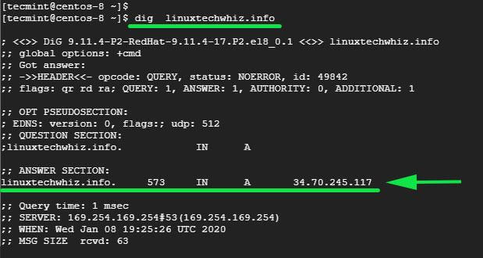
3. Nginx installed and running on the webserver. You can confirm this by logging into the terminal and running the command below. If Nginx not installed, follow our article to Install Nginx on CentOS 8.
$ sudo systemctl status nginx
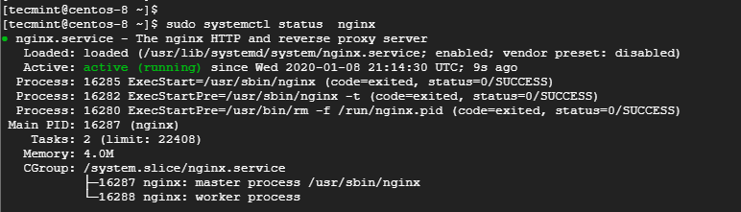
4. You can also verify by visiting the web server’s URL on a web browser.
http://server-IP-or-hostname
From the URL, we can clearly see that the site is not secure, and thus not encrypted. This implies that any requests made to the webserver can be intercepted that this includes critical and confidential information such as usernames, passwords, social security numbers, and credit card information to mention a few.
Now let’s get our hands dirty and install Let’s Encrypt.

Step 1. Install Certbot in CentOS 8
To install Let’s Encrypt certificate, you first-of-all need to have certbot installed. This is an extensible client that fetches a security certificate from Let’s Encrypt Authority and lets you automate the validation and configuration of the certificate for use by the webserver.
Download certbot using the curl command.
$ sudo curl -O https://dl.eff.org/certbot-auto
Next, move the certificate to the /usr/local/bin directory.
$ sudo mv certbot-auto /usr/local/bin/certbot-auto
Next, assign file permission to the certbot file as shown.
$ chmod 0755 /usr/local/bin/certbot-auto

Step 2. Configure Nginx Server Block
A server block in Nginx is the equivalent of a virtual host in Apache. Setting up of server blocks not only allows you to set up multiple websites in one server but also allows certbot to prove ownership of the domain to Certificate Authority – CA.
To create a server block, run the command shown.
$ sudo vim /etc/nginx/conf.d/www.linuxtechwhiz.info
Be sure to replace the domain name with your own domain name. Then paste the configuration below.
server {
server_name www.linuxtechwhiz.info;
root /opt/nginx/www.linuxtechwhiz.info;

location / {
index index.html index.htm index.php;
}

access_log /var/log/nginx/www.linuxtechwhiz.info.access.log;
error_log /var/log/nginx/www.linuxtechwhiz.info.error.log;

location ~ \.php$ {
include /etc/nginx/fastcgi_params;
fastcgi_pass 127.0.0.1:9000;
fastcgi_index index.php;
fastcgi_param SCRIPT_FILENAME $document_root$fastcgi_script_name;
}
}
Save the file and exit the text editor.

Step 3: Install Lets Encrypt Certificate on CentOS 8
Now use certbot command to initialize the fetching and configuration of Let’s Encrypt security certificate.
$ sudo /usr/local/bin/certbot-auto --nginx
This command will run and install multiple Python packages and their dependencies as shown.
This will thereafter be followed by an interactive prompt as shown:
If all went well, you should be able to see a congratulatory message at the very end.
To confirm that your Nginx site is encrypted, reload the webpage and observe the padlock symbol at the beginning of the URL. This indicates that the site is secured using an SSL/TLS encryption.

To get more information about the security certificate, click on the padlock symbol and select the ‘Certificate’ option.
More information about the security certificate will be displayed as shown below.
Additionally, to test the strength of the security certificate, head out to https://www.ssllabs.com/ssltest/ and find a more accurate and in-depth analysis of the status of the security certificate.

Step 4. Renewing the Let’s Encrypt Certificate
As we saw earlier, the security certificate is only valid for a duration of 90 days and needs to be renewed before the expiry.
You can simulate or test the certificate renewal process by running the command:
$ sudo /usr/local/bin/certbot-auto renew --dry-run
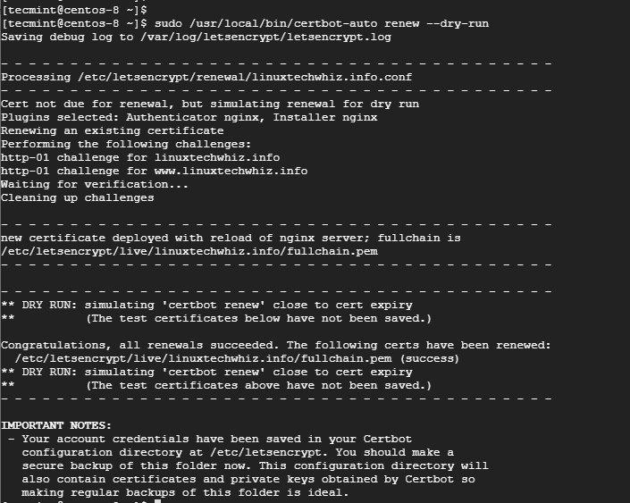

Conclusion
This wraps up this tutorial on securing Nginx with Let’s Encrypt on CentOS 8. Let’s Encrypt offers an effective and hassle-free way of securing your Nginx webserver that would otherwise be a complex affair to do manually.
Your site should now be fully encrypted. A few weeks to the certificate’s expiry date, EFF will alert you via email to renew the certificate to avoid interruption that may arise due to an expired certificate. That’s all guys for today!
https://www.tecmint.com/secure-nginx-with-lets-encrypt-on-centos-8/

Secure Nginx with Let’s Encrypt on CentOS 8
Written by Admin, Updated On April 23, 2020

In this tutorial you will learn step by step instruction to install a free Let’s Encrypt SSL certificate on CentOS 8 running Nginx as a web server.
Let’s Encrypt is a free, automated, and open certificate authority that provides TLS encryption for websites free of cost. This certificate enables encrypted connections to HTTP servers using the HTTPS protocol in a easier and hassle-free manner without any complexities. Certificates issued by Let’s Encrypt are trusted by all major browsers and valid for 90 days from the issue date.

Prerequisites
- A CentOS system logged in with a non-root user with sudo privileges.
- Nginx must installed and configured, as shown in this tutorial.
- Have a Nginx server block for your domain, as shown in this tutorial.
- Your domain name should pointing to your server IP address.
- Your firewall is configured to accept connections on ports 80 and 443

Step 1. Install Certbot in CentOS 8
Certbot client package is a free command-line tool that useful for obtain and renew Let’s Encrypt SSL certificates and configure to web servers.
By default, certbot package is not included in the standard CentOS 8 repositories. We will download it from the vendor’s website.
Download Certbot using wget command as root or sudo user at /usr/local/bin directory:
sudo wget -P /usr/local/bin https://dl.eff.org/certbot-auto
After completion of download, make that file executable by typing:
sudo chmod +x /usr/local/bin/certbot-auto

Step 2. Configure Nginx Server Block
Nginx server block is the equivalent of a virtual host in Apache. By setting up of server blocks it allows you to set up multiple websites on single server and also allows certbot to verify the ownership of the domain to Certificate Authority – CA.
sudo vim /etc/nginx/conf.d/example.com.conf
Make sure to replace the example.com.conf domain name with your own domain name. Add the following line to file:
server {
server_name example.com;
root /opt/nginx/example.com;

location / {
index index.html index.htm index.php;
}

access_log /var/log/nginx/example.com.access.log;
error_log /var/log/nginx/example.com.error.log;

location ~ \.php$ {
include /etc/nginx/fastcgi_params;
fastcgi_pass 127.0.0.1:9000;
fastcgi_index index.php;
fastcgi_param SCRIPT_FILENAME $document_root$fastcgi_script_name;
}
}
Save the close the file.

Step 3: Obtain a certificate for domain
Now run the certbot tool to obtain the SSL certificate files for your domain:
sudo /usr/local/bin/certbot-auto --nginx -d example.com -d www.example.com
If this the first time you invoke certbot, the tool will install the missing dependencies. After that it will prompt to enter email and other few details. If everything is well it will show successfully obtained message at the end.
IMPORTANT NOTES:
- Congratulations! Your certificate and chain have been saved at:
/etc/letsencrypt/live/example.com/fullchain.pem
Your key file has been saved at:
/etc/letsencrypt/live/example.com/privkey.pem
Your cert will expire on 2020-07-22. To obtain a new or tweaked
version of this certificate in the future, simply run certbot-auto
again. To non-interactively renew *all* of your certificates, run
"certbot-auto renew"
- If you like Certbot, please consider supporting our work by:

Donating to ISRG / Let's Encrypt: https://letsencrypt.org/donate
Donating to EFF: https://eff.org/donate-le
That’s it! Your website have Let’s Encrypt certificate and encrypted. You can check it by opening your site using https:// in web browser. You will see a green padlock symbol before your web url.

Step 4. Renewing the Let’s Encrypt Certificate
As we mention earlier, the security certificate is only valid for a duration of 90 days only. To automatically renew the certificates before they expire, we will create a cronjob that will run twice a day and automatically renew any certificate 30 days before expiration.
Use the crontab command to create a new cronjob:
sudo crontab -e
Append the following line:
0 */12 * * * root test -x /usr/local/bin/certbot-auto -a ! -d /run/systemd/system && perl -e 'sleep int(rand(3600))' && /usr/local/bin/certbot-auto -q renew --renew-hook "systemctl reload nginx"
Save and close the file. You can check renewal process by type :
sudo /usr/local/bin/certbot-auto renew --dry-run
The renewal process was successful if there are no errors.

Conclusion
In this tutorial, you learned how to install certbot client, obtain Let’s Encrypt SSL certificate and configured to Nginx on CentOS 8. At last, you have set up a cronjob for automatic certificate renewal.
To know more about how to use Certbot, their documentation is a good starting point.
If you hit any problem or have suggestion, please comment below.
https://tecnstuff.net/secure-nginx-with-lets-encrypt-on-centos-8/

How to Install Nginx and Configure on CentOS 8
11 months ago
by Shahriar Shovon
Nginx is a fast and lightweight web server. The configuration files of Nginx are really simple and easy to work with. It is a great alternative to the Apache web server. In this article, I am going to show you how to install and configure Nginx web server on CentOS 8. So, let’s get started.

Installing Nginx:
Nginx is available in the official package repository of CentOS 8. So, it’s very easy to install.
First, update the DNF package repository cache as follows:
$ sudo dnf makecache
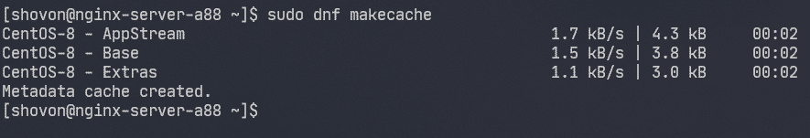
Now, install Nginx with the following command:
$ sudo dnf install nginx
To confirm the installation, press Y and then press <Enter>.
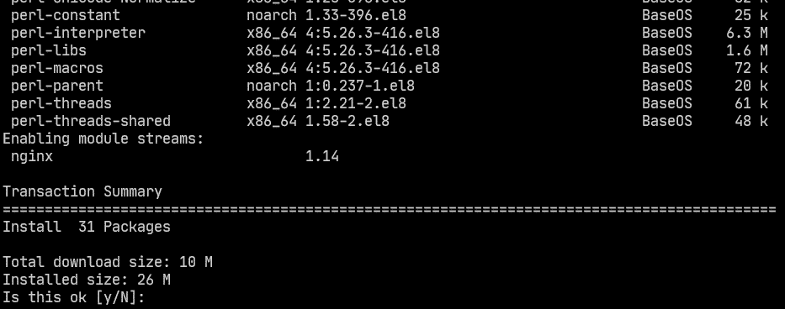
Nginx should be installed.
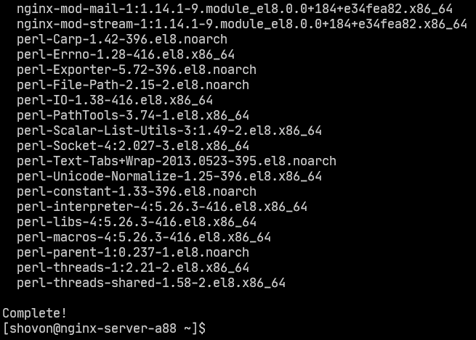

Managing the nginx Service:
By default, nginx service should be inactive (not running) and disabled (won’t automatically start on boot).
$ sudo systemctl status nginx
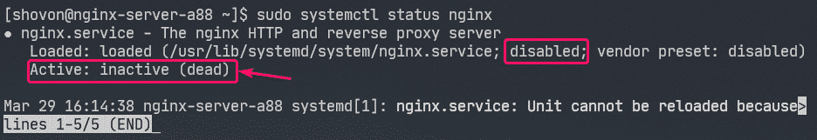
You can start the nginx service as follows:
$ sudo systemctl start nginx
nginx service should be running.
$ sudo systemctl status nginx
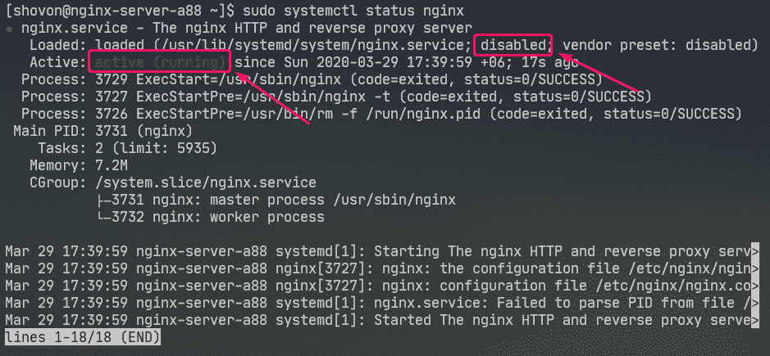
Now, add nginx service to the system startup as follows:
$ sudo systemctl enable nginx
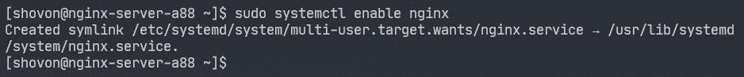

Configuring the Firewall:
You must configure the firewall to allow access to the HTTP port 80 and HTTPS port 443 in order to access the Nginx web server from other computers on the network.
You can allow access to the HTTP and HTTPS port with the following command:
$ sudo firewall-cmd --add-service={http,https} --permanent
Now, for the changes to take effect, run the following command:
$ sudo firewall-cmd --reload
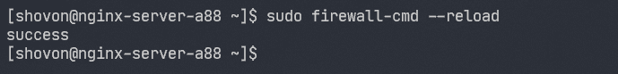

Testing the Web Server:
You must know the IP address or domain name of the Nginx web server in order to access it.
You can find the IP address of your Nginx web server with the following command:
$ ip a
In my case, the IP address is 192.168.20.175. It will be different for you. So, make sure to replace it with yours from now on.
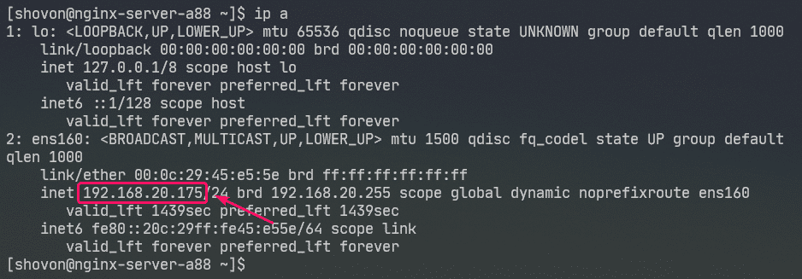
Now, visit http://192.168.20.175 from your web browser. You should see the following page. It means Nginx web server is working.
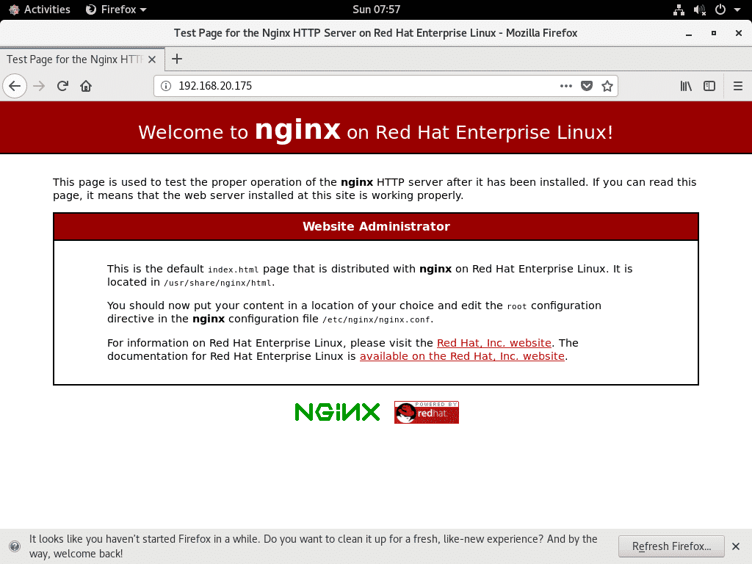

Configuration Files of nginx:
Nginx web server configuration files are in the /etc/nginx/ directory.
$ tree /etc/nginx
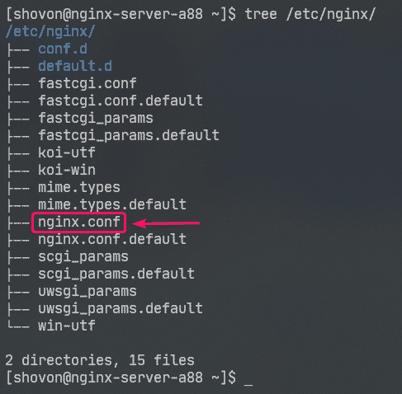
/etc/nginx/nginx.conf is the main Nginx configuration file.
The default web root directory of Nginx web server is /usr/share/nginx/html/. So, this is where you should keep your website files.

Setting up a Basic Web Server:
In this section, I am going to show you how to set up a basic Nginx web server.
First, take a backup of original Nginx configuration file with the following command:
$ sudo mv -v /etc/nginx/nginx.conf /etc/nginx/nginx.conf.original
Now, create a new Nginx configuration file as follows:
$ sudo nano /etc/nginx/nginx.conf
Now, type in the following lines in the /etc/nginx/nginx.conf file and save the file.
user nginx nginx;
worker_processes auto;
error_log /var/log/nginx/error.log;
pid /run/nginx.pid;
events {
worker_connections 1024;
}
http {
include /etc/nginx/mime.types;
default_type application/octet-stream;
server {
listen 80;
server_name example.com www.example.com;
root /usr/share/nginx/html;
index index.html;
access_log /var/log/nginx/access.log;
}
}
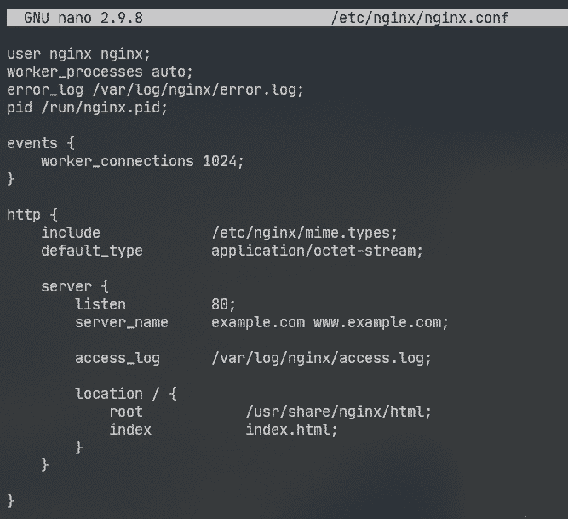
Here, user option is used to set the Nginx run user and group to nginx respectively.
The error_log option is used to set the error log file path to /var/log/nginx/error.log. This is where errors related to the Nginx server will be stored.
The main Nginx server configuration is defined in the server section inside the http section. You can define more than one server section inside the http section if needed.
In the server section,
listen option is used to configure Nginx to listen to port 80 (HTTP port) for web requests.
server_name option is used to set one or more domain names for the Nginx web server. If your DNS settings are correct, you can access Nginx web server using these domain names.
access_log is used to set the access log file path to /var/log/nginx/access.log. When someone tries to access the Nginx web server, the access information (i.e. IP address, URL, HTTP status code) will be logged to this file.
The location option is used to set the root directory of the Nginx web server.
Here, the root directory is /usr/share/nginx/html/.
This is where all the website files should be kept. The index option sets index.html as the default file to serve if no specific file is requested. For example, if you visit http://192.168.20.175/myfile.html , then you Nginx will return myfile.html file. But, if you visit http://192.168.20.175/, then Nginx will send you index.html file as no specific file was requested.
Now, remove all the files from the /usr/share/nginx/html/ directory (web root) as follows:
$ sudo rm -rfv /usr/share/nginx/html/*
Now, create a new index.html file in the /usr/share/nginx/html/ directory as follows:

Now, type in the following lines in index.html file and save the file.
<h1>Hello world</h1>
<p>&copy; 2020 LinuxHint.com</p>
Now, restart nginx service as follows:
$ sudo systemctl restart nginx
Now, visit http://192.168.20.175 from your web browser and you should see the following page. Congrats! You’ve set up your first Nginx web server.

Configuring Error Pages:
You can configure error pages in Nginx. For example, if a page/file/directory is not available, HTTP status code 404 will be returned to the browser. You can set a custom HTML error page for the HTTP status code 404 which will be returned to the browser.
To do that, add the following line in the server section of nginx.conf file.
server {
…
error_page 404 /404.html;
…
}
Now, create a file 404.html in the Nginx web root /usr/share/nginx/html/ as follows:
$ sudo nano /usr/share/nginx/html/404.html
Now, type in the following lines in 404.html and save the file.
<h1>Error 404</h1>
<h2 style="color: red;">Page not found</h2>
<p>&copy; 2020 LinuxHint.com</p>
Now, restart nginx service as follows:
$ sudo systemctl restart nginx
Now, try to access a non-existent path (http://192.168.20.175/nopage.html) and you should see the following error page.
If the 404.html file is in a different filesystem path (let’s say /usr/share/nginx/html/errors/ directory), you can map the URL /404.html to it as follows:
server {
…
error_page 404 /404.html;
location /404.html {
root /usr/share/nginx/html/errors;
}
…
}
Now, make a new directory /usr/share/nginx/html/errors/ as follows:
$ sudo mkdir /usr/share/nginx/html/errors
Now, create a new file 404.html in the directory /usr/share/nginx/html/errors/ as follows:
$ sudo nano /usr/share/nginx/html/errors/404.html
Now, type in the following lines in the 404.html file and save the file.
<h1 style="color: red;">PAGE NOT FOUND</h1>
<a href="/">GO BACK HOME</a>
Now, restart nginx service as follows:
$ sudo systemctl restart nginx
Now, try to access a non-existent path (http://192.168.20.175/nopage.html) and you should see the updated error page.
The same way, you can set error page for other HTTP status codes.
You can also set the same error page for multiple HTTP status codes. For example, to set the same error page /404.html for the HTTP status codes 403 and 404, write the error_page option as follows:
error_page 403 404 /404.html;

Configuring Logs:
In Nginx, the error_log and access_log options are used for logging error messages and access information.
The format of the error_log and access_log options are:
error_log /path/to/error/log/file [optional:custom-log-name];
access_log /path/to/access/log/file [optional:custom-log-name];
You can define your own error log and access log formats if you want.
To do that, use the log_format option in the http section to define your custom log format as follows.
http {
…
log_format simple '[$time_iso8601] $request_method $request_uri '
'[$status] ($request_time) -> $bytes_sent bytes';
…
server {
…
access_log /var/log/nginx/access.log simple;
…
}
}
Here, the log format name is simple. Some nginx variables are used to define the custom log format. Visit the Nginx Embedded Variables Manual to learn about all the Nginx variables.
The custom log format should be enclosed in single quotes. The log format can be defined in a single line or in a multiple lines. I’ve shown how to define the log format in multiple lines in this article. You won’t have any trouble with single line log format, trust me!
Once the log format simple is defined, access_log option is used to tell Nginx to use it as access log.
The same way, you can set a custom error log format using the error_log option.
I’ve only configured custom log format for the access log in this article.
Now, restart nginx service as follows:
$ sudo systemctl restart nginx
Now, you can monitor the access log file as follows:
$ sudo tail -f /var/log/nginx/access.log
You can also monitor the error log file as follows:
$ sudo tail -f /var/log/nginx/error.log
If you want, you can monitor the access log and error log files at the same time as follows:
$ sudo tail -f /var/log/nginx/{error,access}.log
As you can see, the new access log format is being used.

Denying Access to Certain Paths:
You can use regular expressions to match certain URI paths and deny access to it in Nginx.
Let’s say, your website is managed by Git, and you want to deny access to the .git/ directory on your web root.
To do that, type in the following lines in the server section of /etc/nging/nginx.conf file:
server {
…
location ~ \.git {
deny all;
}
…
}
As you can see, access to any path that contains .git is denied.

Configuring Compression:
You can compress web contents before sending them to the browser using gzip to save bandwidth usage of the Nginx web server.
I have some JPEG images in the /usr/share/nginx/html/images/ directory.
I can access these images using the URI path /images.
To enable gzip compression for only the JPEG images in the URI path /images, type in the following lines in the server section of /etc/nginx/nginx.conf file.
server {
…
location /images {
gzip on;
gzip_comp_level 9;
gzip_min_length 100000;
gzip_types image/jpeg;
}
…
}
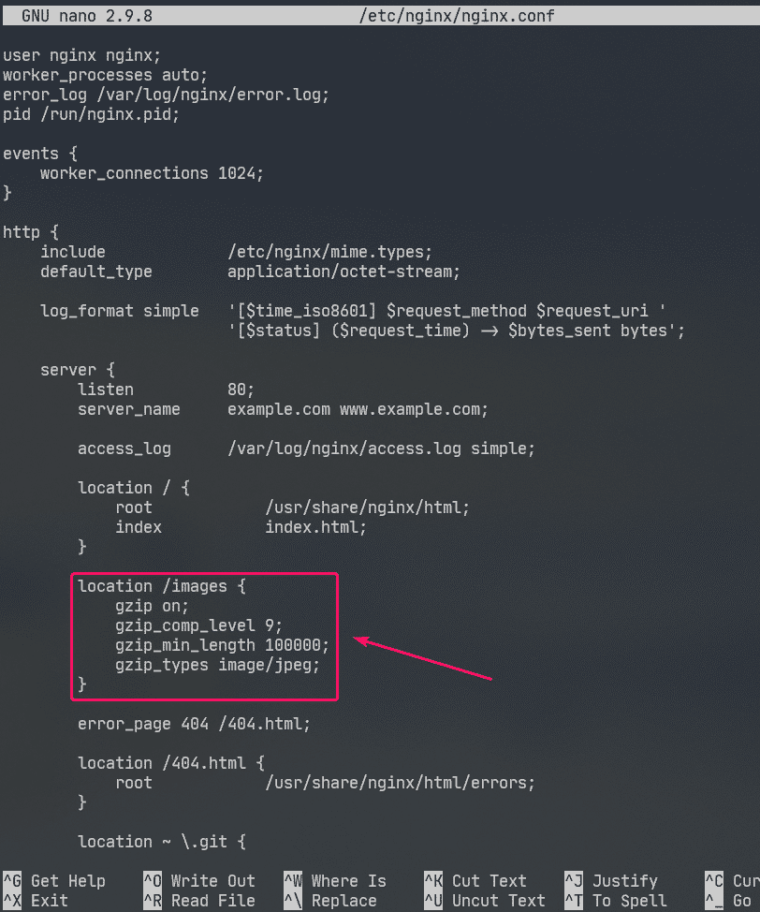
Here, gzip_comp_level is used to set the compression level. It can be any number from 1 to 9. The higher the level, the smaller the compressed file will be.
The file will only be compressed if the size of the file is above gzip_min_length. I’ve set it to about 100 KB in this example. So, JPEG files smaller than 100 KB won’t be gzip compressed.
The gzip_types is used to set the mime type of the files that will be compressed.
You can find mime type from file extensions as follows:
$ grep jpg /etc/nginx/mime.types
As you can see, for .jpg or .jpeg file extension, the mime type is image/jpeg.
You can set one or more mime types using gzip_types option.
If you want to set multiple mime types, then make sure to separate them with spaces as follows:
"
gzip_types image/jpeg image/png image/gif;
Now, restart nginx service as follows:
$ sudo systemctl restart nginx
As you can see, Nginx sends gzip compressed image files to the browser when requested.
As you can see in the screenshot below, the gzip compressed file is smaller than the original file.
$ sudo tail -f /var/log/nginx/access.log

Enabling HTTPS:
You can enable SSL in Nginx very easily. In this section, I am going to show you how to set self-signed SSL certificate in Nginx.
First, navigate to the /etc/ssl/ directory as follows:
$ cd /etc/ssl
Now, generate an SSL key server.key and certificate server.crt with the following command:
$ sudo openssl req -x509 -nodes -days 365 -newkey rsa:2048 -keyout
server.key -out server.crt
NOTE: You must have openssl installed for this to work. If openssl command is unavailable, install openssl with the following command:
$ sudo dnf install openssl -y
Now, type in your 2-letter country code (i.e. US for USA, UK for United Kingdom, RU for Russia, CN for China) and press <Enter>.
Now, type in your State/Province name and press <Enter>.
Now, type in your City name and press <Enter>.
Now, type in your Company name and press <Enter>.
Now, type in the organizational unit name of your company which will use this certificate and press <Enter>.
Now, type in the fully qualified domain name (FQDN) of your Nginx web server and press <Enter>. The SSL certificate will be valid only if the Nginx web server is accessed using this domain name.
Now, type in your email address and press <Enter>.
Your SSL certificate should be ready.
The SSL certificate and key should be generated in the /etc/ssl/ directory.
$ ls -lh
Now, open the Nginx configuration file /etc/nginx/nginx.conf and change listen port to 443 and type in the following lines in the server section.
server {
…
ssl on;
ssl_certificate /etc/ssl/server.crt;
ssl_certificate_key /etc/ssl/server.key;
…
}
Now, restart nginx service as follows:
$ sudo systemctl restart nginx
In real life, you will have correct DNS setup. But for testing purpose, I’ve configured local file-based domain name on the computer I’ve used to access the Nginx web server from.
If you want to follow along, open the /etc/hosts file as follows:
$ sudo nano /etc/hosts
Then, add the following line to the /etc/hosts file.
192.168.20.175 www.example.com
Now, try to visit https://www.example.com and you should see the following page. You will see Your connect is not secure message because it is a self-signed certificate. This is good for testing purpose only.
In real life, you will be buying SSL certificates from Certificate Authorities (CAs) and use them. So, you won’t see this type of message.
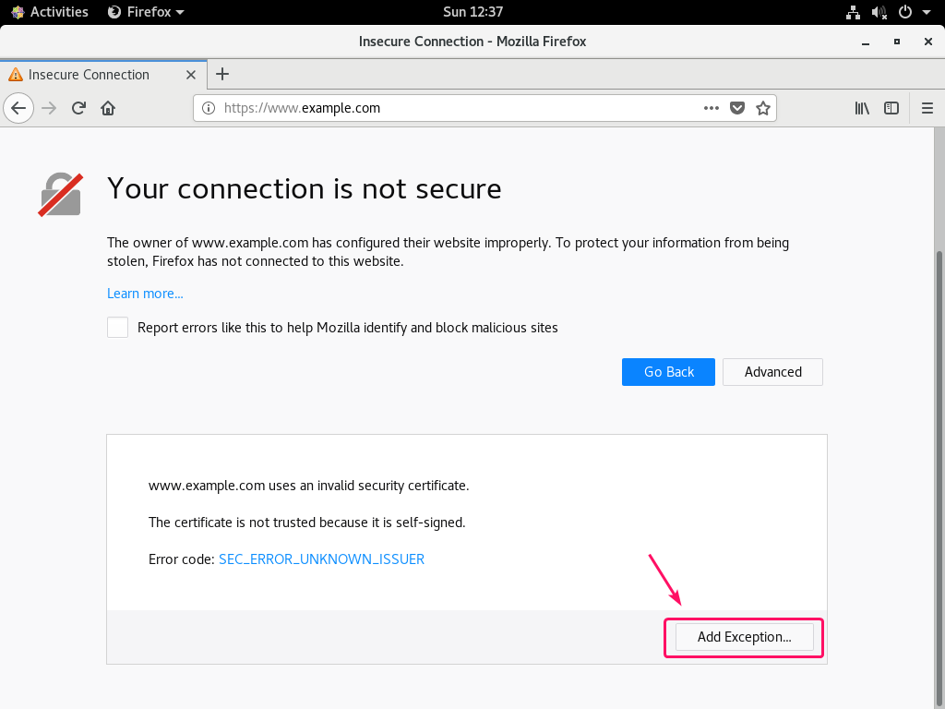
As you can see, Nginx served the web page over HTTPS. So, SSL is working.
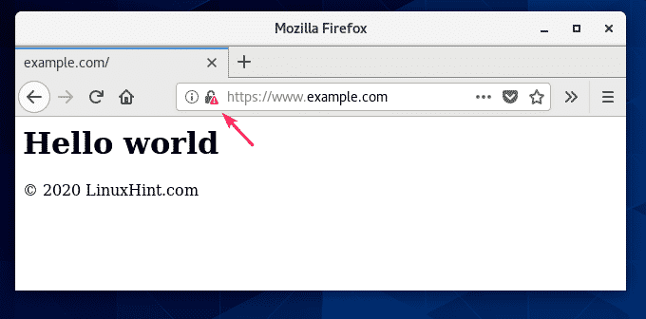
The SSL information of www.example.com.
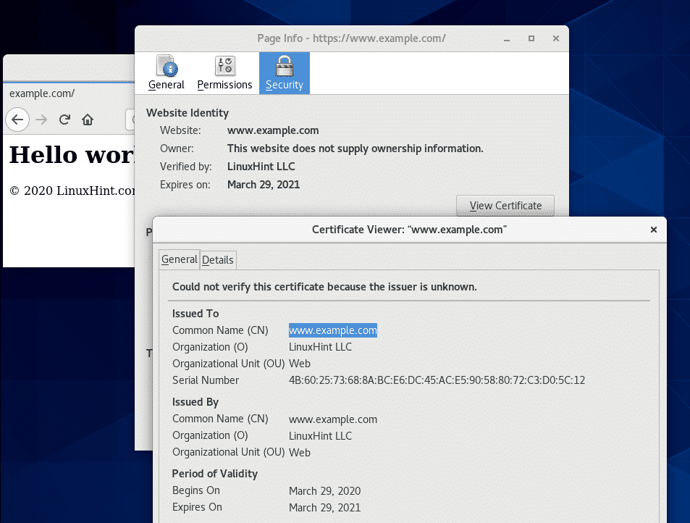

Redirecting HTTP Requests to HTTPS:
If someone visits your website over HTTP protocol (http://www.example.com or http://192.168.20.175) instead of HTTPS (https://www.example.com), you don’t want to reject the HTTP request. If you do that, you will lose a visitor. What you really should do is redirect the user to the SSL enabled site. It is really simple to do.
First, open the Nginx configuration file /etc/nginx/nginx.conf and create a new server section inside the http section as follows:
http {
…
server {
listen 80;
server_name www.example.com;
return 301 https://www.example.com$request_uri;
}
…
}
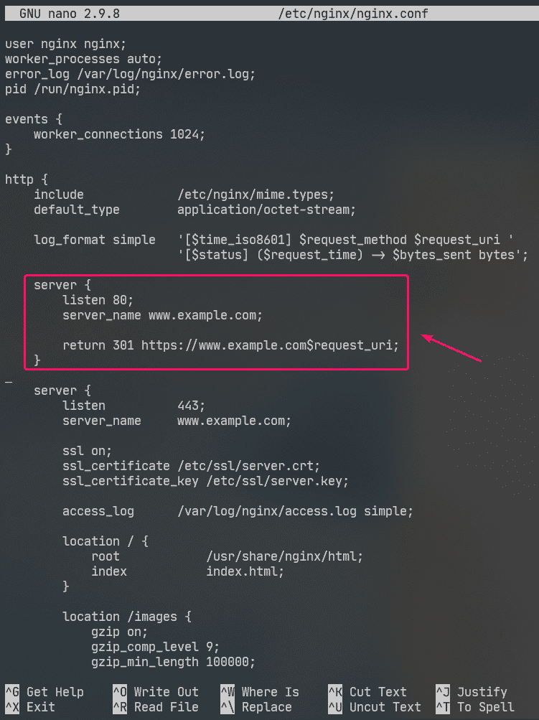
This is the final /etc/nginx/nginx.conf file:
user nginx nginx;
worker_processes auto;
error_log /var/log/nginx/error.log;
pid /run/nginx.pid;
events {
worker_connections 1024;
}
http {
include /etc/nginx/mime.types;
default_type application/octet-stream;
log_format simple '[$time_iso8601] $request_method $request_uri '
'[$status] ($request_time) -> $bytes_sent bytes';
server {
listen 80;
server_name www.example.com;
return 301 https://www.example.com$request_uri;
}
server {
listen 443;
server_name www.example.com;
ssl on;
ssl_certificate /etc/ssl/server.crt;
ssl_certificate_key /etc/ssl/server.key;
access_log /var/log/nginx/access.log simple;
location / {
root /usr/share/nginx/html;
index index.html;
}
location /images {
gzip on;
gzip_comp_level 9;
gzip_min_length 100000;
gzip_types image/jpeg;
}
error_page 404 /404.html;
location /404.html {
root /usr/share/nginx/html/errors;
}
location ~ \.git {
deny all;
}
}
}
Now, restart nginx service as follows:
$ sudo systemctl restart nginx
Now, if you try to access http://192.168.20.175 or http://www.example.com, you will be redirected to https://www.example.com.
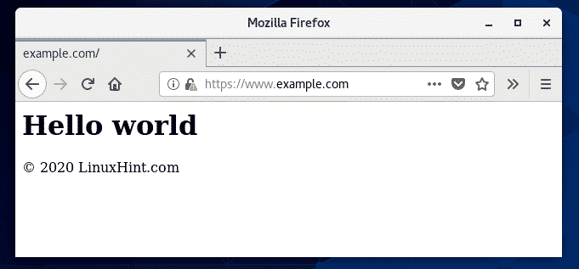
So, that’s how you install and configure Nginx web server on CentOS 8. Thanks for reading this article.
https://linuxhint.com/install_nginx_centos8/

ModSecurity with Nginx on CentOS 8
Created On
Last Updated On
byYongKW
- Main
- Linux
- RHEL
- ModSecurity with Nginx on CentOS 8
< All Topics
Tutorial on how to configure ModSecurity with Nginx on CentOS 8
ModSecurity, sometimes called Modsec, is an open-source web application firewall (WAF) to provide protections against generic classes of vulnerabilities using the OWASP ModSecurity Core Rule Set (CRS)

Preparation of CentOS 8
- Install a fresh copy of CentOS 8 with minimal install in VMware ESXi Host
- Perform System Update
dnf check-update
dnf update

## Free up disk space by deleting all downloaded software package and all cached repository
dnf clean all
- Install required build tools and dependencies
dnf install gcc-c++ flex bison yajl curl-devel curl zlib-devel pcre-devel autoconf automake git curl make libxml2-devel pkgconfig libtool httpd-devel redhat-rpm-config git wget openssl openssl-devel vim nano
- Install EPEL & Remi Repository
dnf install https://dl.fedoraproject.org/pub/epel/epel-release-latest-8.noarch.rpm
dnf install https://rpms.remirepo.net/enterprise/remi-release-8.rpm
dnf --enablerepo=PowerTools install doxygen yajl-devel
- Install GeoIP Module to allows system administrators to redirect or block web traffic according to the client’s geographical location
dnf --enablerepo=remi install GeoIP-devel

Install ModSecurity
- Clone the latest LibModsecurity GitHub repository to /opt/modsec
mkdir /opt/modsec
cd /opt/modsec

git clone --depth 1 -b v3/master --single-branch https://github.com/SpiderLabs/ModSecurity
- Compile and install ModSecurity
cd ModSecurity
git submodule init
git submodule update

./build.sh
./configure

make
make install

Compile Nginx to support ModSecurity
- Download the ModSecurity-nginx connector which provides a communication channel between Nginx and LibModsecurity
cd /opt/modsec
git clone https://github.com/SpiderLabs/ModSecurity-nginx.git
- Create a non-privileged system user and group for Nginx
useradd -r -M -s /sbin/nologin -d /usr/local/nginx nginx
- Download Nginx and extract it to /opt/nginx
cd /opt
wget http://nginx.org/download/nginx-1.17.6.tar.gz
tar xzf nginx-1.17.6.tar.gz
- Compile Nginx from source code
cd nginx-1.17.6

./configure --user=nginx --group=nginx --with-pcre-jit --with-debug --with-http_ssl_module --with-http_v2_module --with-http_realip_module --add-module=/opt/modsec/ModSecurity-nginx

make
make install
- Create a systemd service for Nginx
nano /etc/systemd/system/nginx.service

[Unit]
Description=The nginx HTTP and reverse proxy server
After=network.target remote-fs.target nss-lookup.target

[Service]
Type=forking
PIDFile=/run/nginx.pid
ExecStartPre=/usr/bin/rm -f /run/nginx.pid
ExecStartPre=/usr/sbin/nginx -t
ExecStart=/usr/sbin/nginx
ExecReload=/bin/kill -s HUP $MAINPID
KillSignal=SIGQUIT
TimeoutStopSec=5
KillMode=mixed
PrivateTmp=true

[Install]
WantedBy=multi-user.target
- Create a symbolic link of Nginx binary to /usr/sbin/ path.
ln -s /usr/local/nginx/sbin/nginx /usr/sbin/
- Change the location of pid to /run/nginx.pid in Nginx config file
nano /usr/local/nginx/conf/nginx.conf
pid /run/nginx.pid;
- Enable and start Nginx service
systemctl enable --now nginx
- Allow Firewalld for HTTP & HTTPS
firewall-cmd --permanent --zone=public --add-service=http
firewall-cmd --permanent --zone=public --add-service=https
# Restart Firewalld
systemctl restart firewalld.service

# Verify HTTP & HTTPS is allowed
firewall-cmd --list-all
public (active)
target: default
icmp-block-inversion: no
interfaces: ens192
sources:
services: cockpit dhcpv6-client http https ssh
ports:
- You should be able to access to Nginx Web Server via http://IP-ADDRESS now
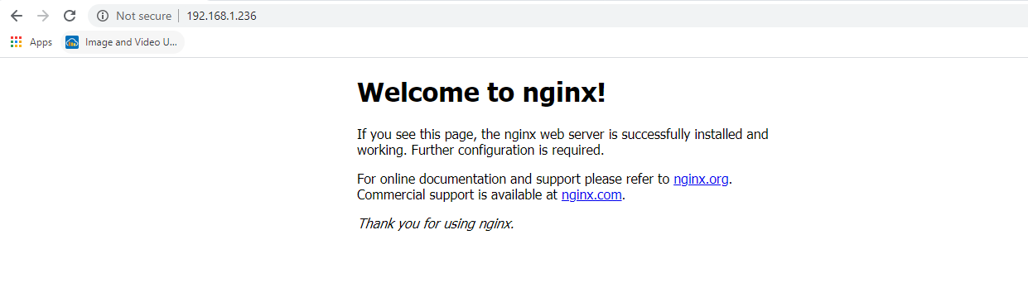

Let’s Encrypt Wildcard SSL Certificate
Generate Let’s Encrypt wildcard SSL Certificate with certbot with DNS Plugin for DnsMadeEasy for *.aventis.dev
#Install Certbot
sudo dnf install certbot
#Install DNS Plugin
sudo dnf install python3-certbot-dns-dnsmadeeasy
Obtain the API & Secret Key from DnsMadeEasy and save it to ~/.secrets/dnsmadeeasy.ini
mkdir ~/.secrets
nano ~/.secrets/dnsmadeeasy.ini

# DNS Made Easy API credentials used by Certbot
dns_dnsmadeeasy_api_key = XXXXXXXXXXXXXXXXXXXXXXXXX
dns_dnsmadeeasy_secret_key = XXXXXXXXXXXXXXXXXXXXXX
Request the SSL Certificate from Let’s Encrypt
[root@centos /]# certbot certonly \
> --dns-dnsmadeeasy \
> --dns-dnsmadeeasy-credentials ~/.secrets/dnsmadeeasy.ini \
> -d *.aventis.dev

Saving debug log to /var/log/letsencrypt/letsencrypt.log
Plugins selected: Authenticator dns-dnsmadeeasy, Installer None
Enter email address (used for urgent renewal and security notices)
(Enter 'c' to cancel): kwyong@aventistech.com

- - - - - - - - - - - - - - - - - - - - - - - - - - - - - - - - - - - - - - - -
Please read the Terms of Service at
https://letsencrypt.org/documents/LE-SA-v1.2-November-15-2017.pdf. You must
agree in order to register with the ACME server at
https://acme-v02.api.letsencrypt.org/directory
- - - - - - - - - - - - - - - - - - - - - - - - - - - - - - - - - - - - - - - -
(A)gree/(C)ancel: A

- - - - - - - - - - - - - - - - - - - - - - - - - - - - - - - - - - - - - - - -
Would you be willing, once your first certificate is successfully issued, to
share your email address with the Electronic Frontier Foundation, a founding
partner of the Let's Encrypt project and the non-profit organization that
develops Certbot? We'd like to send you email about our work encrypting the web,
EFF news, campaigns, and ways to support digital freedom.
- - - - - - - - - - - - - - - - - - - - - - - - - - - - - - - - - - - - - - - -
(Y)es/(N)o: Y
Obtaining a new certificate
Performing the following challenges:
dns-01 challenge for aventis.dev
Waiting 60 seconds for DNS changes to propagate
Waiting for verification...
Cleaning up challenges
Subscribe to the EFF mailing list (email: kwyong@aventistech.com).

IMPORTANT NOTES:
- Congratulations! Your certificate and chain have been saved at:
/etc/letsencrypt/live/aventis.dev/fullchain.pem
Your key file has been saved at:
/etc/letsencrypt/live/aventis.dev/privkey.pem
Your cert will expire on 2020-12-06. To obtain a new or tweaked
version of this certificate in the future, simply run certbot
again. To non-interactively renew *all* of your certificates, run
"certbot renew"
- Your account credentials have been saved in your Certbot
configuration directory at /etc/letsencrypt. You should make a
secure backup of this folder now. This configuration directory will
also contain certificates and private keys obtained by Certbot so
making regular backups of this folder is ideal.
- If you like Certbot, please consider supporting our work by:

Donating to ISRG / Let's Encrypt: https://letsencrypt.org/donate
Donating to EFF: https://eff.org/donate-le
Let’s Encrypt wildcard SSL Certificate is stored in /etc/letsencrypt/live/aventis.dev
[root@centos /]# ls /etc/letsencrypt/live/aventis.dev
cert.pem chain.pem fullchain.pem privkey.pem README

Enable SSL & HTTP/2 Support
Copy the cert.pem & privkey.pem to /usr/local/nginx/ssl/
mkdir /usr/local/nginx/ssl
cp /etc/letsencrypt/live/aventis.dev/cert.pem /usr/local/nginx/ssl/
cp /etc/letsencrypt/live/aventis.dev/privkey.pem /usr/local/nginx/ssl/
Enable SSL Support in /usr/local/nginx/conf/nginx.conf
nano /usr/local/nginx/conf/nginx.conf

server {
#Enable SSL
listen 443 ssl http2;
server_name localhost uat.aventis.dev;

#enable SSL
ssl_certificate /usr/local/nginx/ssl/cert.pem;
ssl_certificate_key /usr/local/nginx/ssl/privkey.pem;
}
Verify the configuration file of Nginx and restart the service
nginx -t
systemctl restart nginx
Go to https://uat.aventis.dev and verify that HTTP/2 is enabled with Google Chrome – Developer Tool
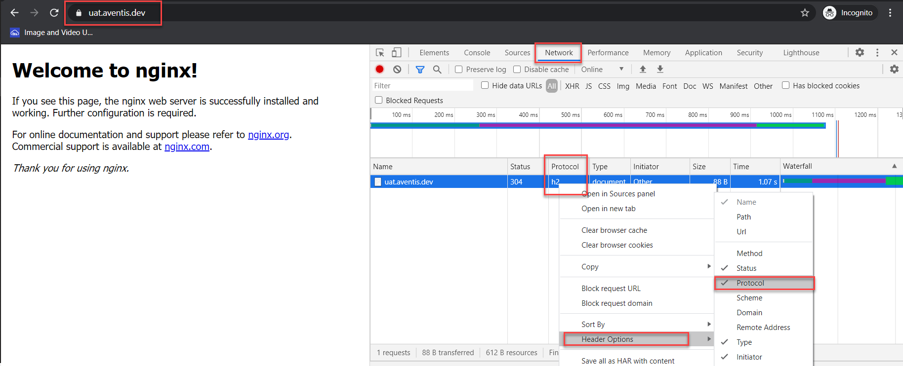

PHP-FPM with NGINX
PHP 7.2 is the default installation profiles
$ sudo dnf module list php

Last metadata expiration check: 0:48:01 ago on Mon 07 Sep 2020 03:54:30 PM +08.
CentOS-8 - AppStream
Name Stream Profiles Summary
php 7.2 [d] common [d], devel, minimal PHP scripting language
php 7.3 common [d], devel, minimal PHP scripting language

Remi's Modular repository for Enterprise Linux 8 - x86_64
Name Stream Profiles Summary
php remi-7.2 common [d], devel, minimal PHP scripting language
php remi-7.3 common [d], devel, minimal PHP scripting language
php remi-7.4 [e] common [d], devel, minimal PHP scripting language
Install the latest PHP 7.4 Module
$ sudo dnf module reset php
#Enable PHP 7.4
$ sudo dnf module enable php:remi-7.4
#Install PHP 7.4
$ sudo dnf install php php-opcache php-gd php-curl php-mysqlnd
#Verify the PHP version installed
[kwyong@centos ~]$ php -v
PHP 7.4.10 (cli) (built: Sep 1 2020 13:58:08) ( NTS )
Copyright (c) The PHP Group
Zend Engine v3.4.0, Copyright (c) Zend Technologies
with Zend OPcache v7.4.10, Copyright (c), by Zend Technologies
Change the PHP-FPM to use nginx instead of Apache user in
$ nano /etc/php-fpm.d/www.conf

user = nginx
group = nginx
Enable and start PHP-FPM
$ sudo systemctl enable php-fpm
$ sudo systemctl start php-fpm
Configure PHP-FPM with Nginx by modifying /usr/local/nginx/conf/nginx.conf
$ sudo nano /usr/local/nginx/conf/nginx.conf

location ~ \.php$ {
root html;
fastcgi_pass unix:/run/php-fpm/www.sock;
fastcgi_index index.php;
fastcgi_param SCRIPT_FILENAME $document_root$fastcgi_script_name;
include fastcgi_params;
}
Restart Nginx & PHP-FPM services
$ sudo systemctl restart nginx
$ sudo systemctl restart php-fpm
Create info.php in /usr/local/nginx/html (Default Root Directory for Nginx)
$ nano /usr/local/nginx/html/info.php
<?php
phpinfo();
?>
Go to https://uat.aventis.dev/info.php to verify PHP is installed successfully
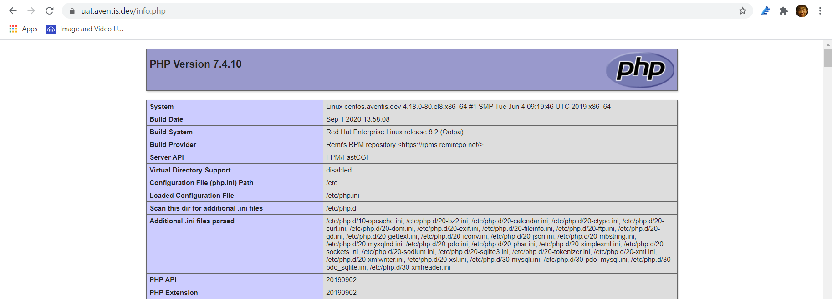

Confgure Nginx with ModSecurity
- Copy the Sample ModSecurity config file and unicode.mapping from ModSecurity source directory to Nginx configuration directory
cp /opt/modsec/ModSecurity/modsecurity.conf-recommended /usr/local/nginx/conf/modsecurity.conf
cp /opt/modsec/ModSecurity/unicode.mapping /usr/local/nginx/conf/
- Create a backup for Nginx config file
cp /usr/local/nginx/conf/nginx.conf /usr/local/nginx/conf/nginx.conf.bak
- Create /var/log/nginx to keep all the access & error log
mkdir /var/log/nginx
- Add the following to the nginx.conf file
nano /usr/local/nginx/conf/nginx.conf

user nginx;

http {
server {
modsecurity on;
modsecurity_rules_file /usr/local/nginx/conf/modsecurity.conf;
access_log /var/log/nginx/access.log;
error_log /var/log/nginx/error.log;
}
- Restart Nginx service
systemctl restart nginx
By default, ModSecurity is set on detection only mode where it only logs the requests based on the triggered rules without blocking anything
- Turn On ModSecurity Rule Engine
nano /usr/local/nginx/conf/modsecurity.conf
- Change the default log directory for ModSecurity to /var/log/nginx/modsec_audit.log
# Use a single file for logging. This is much easier to look at, but
# assumes that you will use the audit log only ocassionally.
SecAuditLogType Serial
SecAuditLog /var/log/nginx/modsec_audit.log

Install OWASP ModSecurity Core Rule Set (CRS)
The OWASP ModSecurity Core Rule Set (CRS) is a set of generic attack detection rules for use with ModSecurity. It aims at protecting the web applications from a wide range of attacks, including the OWASP Top Ten, minimum of false alerts.
- Clone the CRS from GitHub Repository to /usr/local/nginx/conf
git clone https://github.com/SpiderLabs/owasp-modsecurity-crs.git /usr/local/nginx/conf/owasp-crs
- Rename the crs-setup.conf.example to crs-setup.conf
cp /usr/local/nginx/conf/owasp-crs/crs-setup.conf.example /usr/local/nginx/conf/owasp-crs/crs-setup.conf
- Include the OWASP rule to /usr/local/nginx/conf/modsecurity.conf
nano /usr/local/nginx/conf/modsecurity.conf
Include owasp-crs/crs-setup.conf
Include owasp-crs/rules/*.conf
- Verify Nginx configuration file and restart Nginx service
nginx -t
systemctl restart nginx

Testing ModSecurity on Nginx
Run the following command injection
[root@prod-centos conf]# curl localhost/index.html?exec=/bin/bash
<html>
<head><title>403 Forbidden</title></head>
<body>
<center><h1>403 Forbidden</h1></center>
<hr><center>nginx/1.17.6</center>
</body>
</html>
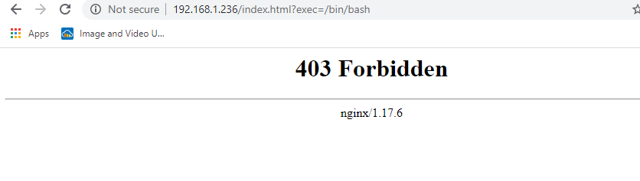
Check the log file
[root@prod-centos conf]# tail /var/log/nginx/modsec_audit.log
ModSecurity: Warning. Matched "Operator `Rx' with parameter `^[\d.:]+$' against variable `REQUEST_HEADERS:Host' (Value: `192.168.1.236' ) [file "/usr/local/nginx/conf/owasp-crs/rules/REQUEST-920-PROTOCOL-ENFORCEMENT.conf"] [line "722"] [id "920350"] [rev ""] [msg "Host header is a numeric IP address"] [data "192.168.1.236"] [severity "4"] [ver "OWASP_CRS/3.2.0"] [maturity "0"] [accuracy "0"] [tag "application-multi"] [tag "language-multi"] [tag "platform-multi"] [tag "attack-protocol"] [tag "paranoia-level/1"] [tag "OWASP_CRS"] [tag "OWASP_CRS/PROTOCOL_VIOLATION/IP_HOST"] [tag "WASCTC/WASC-21"] [tag "OWASP_TOP_10/A7"] [tag "PCI/6.5.10"] [hostname "192.168.1.236"] [uri "/index.html"] [unique_id "1591167373"] [ref "o0,13v46,13"]
ModSecurity: Warning. Matched "Operator `PmFromFile' with parameter `unix-shell.data' against variable `ARGS:exec' (Value: `/bin/bash' ) [file "/usr/local/nginx/conf/owasp-crs/rules/REQUEST-932-APPLICATION-ATTACK-RCE.conf"] [line "496"] [id "932160"] [rev ""] [msg "Remote Command Execution: Unix Shell Code Found"] [data "Matched Data: bin/bash found within ARGS:exec: /bin/bash"] [severity "2"] [ver "OWASP_CRS/3.2.0"] [maturity "0"] [accuracy "0"] [tag "application-multi"] [tag "language-shell"] [tag "platform-unix"] [tag "attack-rce"] [tag "paranoia-level/1"] [tag "OWASP_CRS"] [tag "OWASP_CRS/WEB_ATTACK/COMMAND_INJECTION"] [tag "WASCTC/WASC-31"] [tag "OWASP_TOP_10/A1"] [tag "PCI/6.5.2"] [hostname "192.168.1.236"] [uri "/index.html"] [unique_id "1591167373"] [ref "o1,8v21,9t:urlDecodeUni,t:cmdLine,t:normalizePath,t:lowercase"]
ModSecurity: Access denied with code 403 (phase 2). Matched "Operator `Ge' with parameter `5' against variable `TX:ANOMALY_SCORE' (Value: `8' ) [file "/usr/local/nginx/conf/owasp-crs/rules/REQUEST-949-BLOCKING-EVALUATION.conf"] [line "80"] [id "949110"] [rev ""] [msg "Inbound Anomaly Score Exceeded (Total Score: 8)"] [data ""] [severity "2"] [ver "OWASP_CRS/3.2.0"] [maturity "0"] [accuracy "0"] [tag "application-multi"] [tag "language-multi"] [tag "platform-multi"] [tag "attack-generic"] [hostname "192.168.1.236"] [uri "/index.html"] [unique_id "1591167373"] [ref ""]
Reference Links
- https://kifarunix.com/configure-libmodsecurity-with-nginx-on-centos-8/
https://aventistech.com/kb/modsecurity-with-nginx-on-centos-8/?seq_no=2

Configure LibModsecurity with Nginx on CentOS 8
By
koromicha
-
0
2550

In this guide, we are going to learn how to configure LibModsecurity with Nginx on CentOS 8. LibMosecurity is the newest version of ModSecurity version 2.9 and below. It is therefore known as ModSecurity version 3.

Configure LibModsecurity with Nginx on CentOS 8

Run System Update
Begin by updating your system packages.
dnf update

Install Required Build Tools and Dependencies
Both Nginx and LibModsecurity are going to be compiled from the source and thus a number of build tools and dependencies are required. Run the command below to install them.
dnf install gcc-c++ flex bison yajl curl-devel curl zlib-devel pcre-devel autoconf automake git curl make libxml2-devel pkgconfig libtool httpd-devel redhat-rpm-config git wget openssl openssl-devel vim
dnf --enablerepo=PowerTools install doxygen yajl-devel
Install GeoIP Libraries
dnf install https://dl.fedoraproject.org/pub/epel/epel-release-latest-8.noarch.rpm
dnf install https://rpms.remirepo.net/enterprise/remi-release-8.rpm
dnf --enablerepo=remi install GeoIP-devel

Download LibModsecurity Source Code
Create a temporary directory to store the source tarballs.
mkdir /tmp/modsec
You can choose to use /opt instead.
Run the command below to clone the latest LibModsecurity GitHub repository.
cd /tmp/modsec
git clone --depth 1 -b v3/master --single-branch https://github.com/SpiderLabs/ModSecurity

Compile and Install LibModsecurity
Navigate to the LibModsecurity source directory, configure, compile and install it
cd ModSecurity
Download libInjection code which is available as part of ModSecurity source code in a format of a git-submodule
git submodule init
git submodule update
Configure LibModsecurity to adapt it to your system and check if any required dependency is missing.
./build.sh
./configure
The fatal: No names found, cannot describe anything can be safely ignored. Fix any dependency issue just in case there is any.
Compile and install LibModSecurity.
make
make install

Install Nginx with LibModsecurity Support
To setup Nginx with LibModsecurity, you need to compile Nginx with support for LibModsecurity.
Therefore, download the ModSecurity-nginx connector which provides a communication channel between Nginx and LibModsecurity by cloning its git repository.
cd /tmp/modsec
git clone https://github.com/SpiderLabs/ModSecurity-nginx.git
Next, download the latest staple version of Nginx from Nginx downloads. The latest version as of this writing is version nginx-1.17.6.tar.gz.
wget http://nginx.org/download/nginx-1.17.6.tar.gz
Extract the archive.
tar xzf nginx-1.17.6.tar.gz
Create a non-privileged Nginx system user and group.
useradd -r -M -s /sbin/nologin -d /usr/local/nginx nginx
Navigate to Nginx source directory and configure it.
cd nginx-1.17.6
./configure --user=nginx --group=nginx --with-pcre-jit --with-debug --with-http_ssl_module --with-http_realip_module --add-module=/tmp/modsec/ModSecurity-nginx
Compile and install Nginx.
make
make install

Confgure Nginx with ModSecurity
To begin with, copy the sample ModSecurity configuration file on the source directory to Nginx configuration directory.
cp /tmp/modsec/ModSecurity/modsecurity.conf-recommended /usr/local/nginx/conf/modsecurity.conf
Copy the unicode.mapping file from ModSecurity source directory to Nginx configuration directory.
cp /tmp/modsec/ModSecurity/unicode.mapping /usr/local/nginx/conf/
Next, edit Nginx configuration file and make the changes as shown below.
Create a backup of the Nginx configuration file.
cp /usr/local/nginx/conf/nginx.conf /usr/local/nginx/conf/nginx.conf.bak
Open the configuration file for editing.
vim /usr/local/nginx/conf/nginx.conf
Configure Nginx such that your configuration may look like;
user nginx;
worker_processes 1;
pid /run/nginx.pid;
events {
worker_connections 1024;
}
http {
include mime.types;
default_type application/octet-stream;
sendfile on;
keepalive_timeout 65;
server {
listen 80;
server_name nginx.kifarunix-demo.com;
modsecurity on;
modsecurity_rules_file /usr/local/nginx/conf/modsecurity.conf;
access_log /var/log/nginx/access_kifarunix-demo.log;
error_log /var/log/nginx/error_kifarunix-demo.log;
location / {
root html;
index index.html index.htm;
}
error_page 500 502 503 504 /50x.html;
location = /50x.html {
root html;
}
}
}
Note that the line;
modsecurity on;
modsecurity_rules_file /usr/local/nginx/conf/modsecurity.conf;
Turns on Modsecurity and specifies the location of the Modsecurity rules.
Note that ModSecurity 3 can be turned on per directory basis.
Create Nginx log directory.
mkdir /var/log/nginx

Create Nginx Systemd Service
To be able to run Nginx as a service, create a systemd service as shown below;
vim /etc/systemd/system/nginx.service
[Unit]
Description=The nginx HTTP and reverse proxy server
After=network.target remote-fs.target nss-lookup.target

[Service]
Type=forking
PIDFile=/run/nginx.pid
ExecStartPre=/usr/bin/rm -f /run/nginx.pid
ExecStartPre=/usr/sbin/nginx -t
ExecStart=/usr/sbin/nginx
ExecReload=/bin/kill -s HUP $MAINPID
KillSignal=SIGQUIT
TimeoutStopSec=5
KillMode=mixed
PrivateTmp=true

[Install]
WantedBy=multi-user.target
Create a symbolic link of Nginx binary to /usr/sbin/ path.
ln -s /usr/local/nginx/sbin/nginx /usr/sbin/
Reload systemd configurations.
systemctl daemon-reload
Run Nginx configuration syntax error verification.
nginx -t
nginx: the configuration file /usr/local/nginx/conf/nginx.conf syntax is ok
nginx: configuration file /usr/local/nginx/conf/nginx.conf test is successful
If all is well, start and enable Nginx to run on system boot.
systemctl enable --now nginx
Check the status;
systemctl status nginx
● nginx.service - The nginx HTTP and reverse proxy server
Loaded: loaded (/etc/systemd/system/nginx.service; enabled; vendor preset: disabled)
Active: active (running) since Sat 2019-11-30 09:52:05 EAT; 9s ago
Process: 2679 ExecStart=/usr/sbin/nginx (code=exited, status=0/SUCCESS)
Process: 2678 ExecStartPre=/usr/sbin/nginx -t (code=exited, status=0/SUCCESS)
Process: 2676 ExecStartPre=/usr/bin/rm -f /run/nginx.pid (code=exited, status=0/SUCCESS)
Main PID: 2681 (nginx)
Tasks: 2 (limit: 11524)
Memory: 3.5M
CGroup: /system.slice/nginx.service
├─2681 nginx: master process /usr/sbin/nginx
└─2682 nginx: worker process
...

Turn on ModSecurity Rule Engine
By default, ModSecurity is set on detection only mode where it only logs the requests based on the triggered rules without blocking anything. This can be changed by setting the value of SecRuleEngine to On.
sed -i 's/SecRuleEngine DetectionOnly/SecRuleEngine On/' /usr/local/nginx/conf/modsecurity.conf
You can also change default log directory for Modsecurity
sed -i 's#/var/log/modsec_audit.log#/var/log/nginx/modsec_audit.log#' /usr/local/nginx/conf/modsecurity.conf

Install OWASP ModSecurity Core Rule Set (CRS)
The OWASP ModSecurity Core Rule Set (CRS) is a set of generic attack detection rules for use with ModSecurity. It aims at protecting the web applications from a wide range of attacks, including the OWASP Top Ten, minimum of false alerts.
Clone the CRS from GitHub repository to /usr/local/nginx/conf/ as shown below;
git clone https://github.com/SpiderLabs/owasp-modsecurity-crs.git /usr/local/nginx/conf/owasp-crs
Next, rename crs-setup.conf.example to crs-setup.conf.
sudo cp /usr/local/nginx/conf/owasp-crs/crs-setup.conf{.example,}
Once the OWASP rules are in place, configure ModSecurity to use these rules. You therefore need to enter the following lines on the ModSecurity configuration file to tell it where to find the rules.
echo -e "Include owasp-crs/crs-setup.conf\nInclude owasp-crs/rules/*.conf" >> /usr/local/nginx/conf/modsecurity.conf
This command will append the lines below on /usr/local/nginx/conf/modsecurity.conf.
Include owasp-crs/crs-setup.conf
Include owasp-crs/rules/*.conf
Verify Nginx configuration file again.
nginx -t
Next, restart Nginx if everything is Okay.
systemctl restart nginx

Testing ModSecurity on Nginx
Next, you can test the effectiveness of Modsecurity with OWASP rules, for example, using the command injection. Run the command below;
curl localhost/index.html?exec=/bin/bash
You should get 403 Forbidden if the rules are file.
<html>
<head><title>403 Forbidden</title></head>
<body>
<center><h1>403 Forbidden</h1></center>
<hr><center>nginx/1.17.6</center>
</body>
</html>
Check the logs file.
tail /var/log/nginx/mod
ModSecurity: Warning. Matched "Operator `PmFromFile' with parameter `unix-shell.data' against variable `ARGS:exec' (Value: `/bin/bash' ) [file "/usr/local/nginx/conf/owasp-crs/rules/REQUEST-932-APPLICATION-ATTACK-RCE.conf"] [line "496"] [id "932160"] [rev ""] [msg "Remote Command Execution: Unix Shell Code Found"] [data "Matched Data: bin/bash found within ARGS:exec: /bin/bash"] [severity "2"] [ver "OWASP_CRS/3.2.0"] [maturity "0"] [accuracy "0"] [tag "application-multi"] [tag "language-shell"] [tag "platform-unix"] [tag "attack-rce"] [tag "paranoia-level/1"] [tag "OWASP_CRS"] [tag "OWASP_CRS/WEB_ATTACK/COMMAND_INJECTION"] [tag "WASCTC/WASC-31"] [tag "OWASP_TOP_10/A1"] [tag "PCI/6.5.2"] [hostname "127.0.0.1"] [uri "/index.html"] [unique_id "157509875732.654695"] [ref "o1,8v21,9t:urlDecodeUni,t:cmdLine,t:normalizePath,t:lowercase"]
ModSecurity: Access denied with code 403 (phase 2). Matched "Operator `Ge' with parameter `5' against variable `TX:ANOMALY_SCORE' (Value: `5' ) [file "/usr/local/nginx/conf/owasp-crs/rules/REQUEST-949-BLOCKING-EVALUATION.conf"] [line "79"] [id "949110"] [rev ""] [msg "Inbound Anomaly Score Exceeded (Total Score: 5)"] [data ""] [severity "2"] [ver ""] [maturity "0"] [accuracy "0"] [tag "application-multi"] [tag "language-multi"] [tag "platform-multi"] [tag "attack-generic"] [hostname "127.0.0.1"] [uri "/index.html"] [unique_id "157509875732.654695"] [ref ""]
ModSecurity: Warning. Matched "Operator `Ge' with parameter `5' against variable `TX:INBOUND_ANOMALY_SCORE' (Value: `5' ) [file "/usr/local/nginx/conf/owasp-crs/rules/RESPONSE-980-CORRELATION.conf"] [line "76"] [id "980130"] [rev ""] [msg "Inbound Anomaly Score Exceeded (Total Inbound Score: 5 - SQLI=0,XSS=0,RFI=0,LFI=0,RCE=5,PHPI=0,HTTP=0,SESS=0): individual paranoia level scores: 5, 0, 0, 0"] [data ""] [severity "0"] [ver ""] [maturity "0"] [accuracy "0"] [tag "event-correlation"] [hostname "127.0.0.1"] [uri "/index.html"] [unique_id "157509875732.654695"] [ref ""]
You can also create your own test rules. For example, append the line below on your /usr/local/nginx/conf/modsecurity.conf.
SecRule ARGS "@streq test" "id:1,phase:1,deny,msg:\'Mytest Rule\'"
Save the configuration file. You can also create your custom rules file and make sure it is included on the main ModSecurity configuration file.
Restart Nginx.
systemctl restart nginx
Test the rule.
curl localhost/index.html?a=test
<html>
<head><title>403 Forbidden</title></head>
<body>
<center><h1>403 Forbidden</h1></center>
<hr><center>nginx/1.17.6</center>
</body>
</html>
Check the log file.
ModSecurity: Access denied with code 403 (phase 1). Matched "Operator `StrEq' with parameter `test' against variable `ARGS:a' (Value: `test' ) [file "/usr/local/nginx/conf/modsecurity.conf"] [line "254"] [id "1"] [rev ""] [msg "\'Mytest Rule\'"] [data ""] [severity "0"] [ver ""] [maturity "0"] [accuracy "0"] [hostname "127.0.0.1"] [uri "/index.html"] [unique_id "157509886780.823503"] [ref "v18,4"]
The ModSecurity is now running and protecting your web server. That marks the end of our tutorial on how to configure LibModsecurity with Nginx on CentOS 8.
If you want to run any specific web application that requires LAMP stack/LEMP stack installed, you can follow the links below to set up LEMP/LAMP stack on CentOS 8.
Install LEMP Stack on CentOS 8
Install LAMP Stack on CentOS 8
You can check our other guides on ModSecurity by following the links below;
Install LibModsecurity with Apache on Ubuntu 18.04
Install LibModsecurity with Apache on Fedora 30/29/CentOS 7
https://kifarunix.com/configure-libmodsecurity-with-nginx-on-centos-8/

